TITLE PAGE

**Patterns of influence in wild moving meerkat groups**

Baptiste Averly1,2,3, Vivek H. Sridhar2,3, Vlad Demartsev1,2,3,4, Gabriella Gall1,2,3,4,5, Marta Manser4,5,*, Ariana Strandburg-Peshkin1,2,3,4,*

1. Department of Biology, University of Konstanz, Konstanz, Germany
2. Department for the Ecology of Animal Societies, Max Planck Institute of Animal Behavior, Konstanz, Germany
3. Centre for the Advanced Study of Collective Behaviour, University of Konstanz, Konstanz, Germany
4. Department of Evolutionary Biology and Environmental Studies, University of Zurich, Zurich, Switzerland
5. Kalahari Meerkat Project, Kuruman River Reserve, Northern Cape, South Africa

*joint senior author

**ABSTRACT**

**INTRODUCTION**

Social animal groups in the wild constantly have to make decisions during movement while somehow managing to remain cohesive. Consensus is often achieved by the emergence of more influential individuals followed by the rest of the group, but more democratic systems also exist.

Different types of decisions likely entail different processes. In particular, decisions about direction (where to go) and timing (when to go) of movement fundamentally differ. Influence patterns might thus vary depending on decision types. In addition, leadership tendency is likely a very versatile trait: probably differences in patterns between group of a same species, + influence might be expressed in more than one way, or differently in different contexts

Thanks to new technologies, more and more studies are able to look at leadership and influence patterns in wild social groups. This should enable a comprehensive assessment of factors that influence leadership. However, so far many studies have been restricted by technical or logistical limitations. As a result some studies were only able to investigate one group at a time. Example …, are inferring leadership from a single metric - example: who’s in the front). Finally, other studies were unable to discriminate between different decision types like direction and timing. Brief review of previous literature on influence / leadership, including the ways it was quantified and what the results were

Here, we developed a framework to infer leadership in moving animal groups through multiple approaches. This framework explicitly allows us to account for differences in decision-making regarding direction and timing of travel.

We use a dataset made up of very-high resolution gps tracks of wild habituated meerkats in 5 different groups of varying sizes.

Wie studied decision making during movement in groups of meerkats *Latin name*. Meerkats: small highly social mammals leaving in the arid parts of southern Africa. Spend their day travelling as a highly cohesive group while each individual forages independently by digging the ground for food. Mechanisms by which they manage to maintain cohesion and make decision during movement is not well-known. Meerkat groups are socially structured with two dominant individuals monopolizing most of the breeding. However, it is unclear whether higher social status also translates to more influence or leadership for non-breeding activities, such as movement. Also highly developed vocal communication, with several calls directly related with coordination during movement. Their particular social structure, active communication and movement dynamics, make meerkat an interesting model species to further our understanding of the diversity of collective movement mechanisms in the wild.

Our questions: (1) Are there particular individuals of particular statuses with more influence over others during movement, and are these patterns consistent across groups? (2) Are meerkats more influenced by the position or the movement of other more influential individuals? (3) Do individuals which have high influence over direction of movement also have a lot of influence regarding timing and vice-versa?

**METHODS**

**Study site and data collection**

*Study system*

The study was conducted at the Kalahari Meerkat Project, within the Kuruman River Reserve in South Africa. We collected the data during winter months on five distinct habituated meerkat groups: HM17 (7 individuals) in August and September 2017, HM19 (18 individuals) in June and July 2019, L19 (19 individuals) in August 2019, ZU21 (13 individuals) in XX and NQ21 (11 individuals) in XX. Groups were chosen for their high level of habituation to humans and positive responses to wearing a collar. Individuals were assigned to one of six different classes that confer status: juveniles (<3 months), sub-adults (<1 year), yearlings (<2 years), adults (2+ years), dominant males and dominant females. Three individuals were recorded both in HM17 and HM19.

*Tag design*

To simultaneously record the trajectories of all individuals in a social group, we designed small (<25 g) collars consisting of a GPS unit (Gipsy 5, Techosmart, Colleverde, Italy) and its battery (ER14250M) fixed on 5 mm-wide leather strap and protected from shocks and sand by wrapping in parafilm and covering with 2-part epoxy glue. The length of the strap was adjusted individually for each meerkat based on prior neck measurements. The closing mechanism constituted of 2 magnets (1*5*5mm) glued to 3-D printed plastic clasps at each end of the leather strap, designed to be able to close easily but to require human intervention to open. The combined tag and collar weight was between 22 and 25g. Once fitted on a meerkat, the GPS board sat on the back of the neck, with the whip antenna pointing down the back of the individual (Figure 1a).

*Tag deployment duty cycle and retrieval*

All GPS units of a given group were synchronized to start on the same day and to record at 1 fix/second for 3 hours every day during free foraging times. Foraging times occured in the morning after the group had left the sleeping burrow, or in the afternoon before return to their burrow depending on the recording round. We recorded movements for each group for 6 days to 14 days (with two deployments) depending on groups. We deployed the collars in the morning between the time individuals emerged from the communal burrow and when they began foraging.

*Focal recordings of untagged individuals and scans*

Some non-juvenile individuals that could not be collared via the methods described above were instead continuously recorded by a human observer. A GPS tag equivalent to those deployed in collars was strapped to the end of a telescopic pole and thus kept within 1 meter of the foraging meerkat for the duration of each session. We then processed the data of the uncollared exactly in the same way as data from meerkats wearing a collar. Another observer performed scans by noting in a tablet when specific events would happen (predator alarm, encounter with another group, etc…).

*Data pre-processing*

To increase GPS reliability and reduce sampling biases we pre-processed the data before subsequent analyses. When GPS signals were not recorded continuously we discarded all fixes taken 30s before signal loss and 30s after retrieval. Similarly, we removed fixes of fewer than 5 satellites.  We also removed data suggesting unrealistic speeds such a distance of more than 10 m between 2 one-second fixes, as these likely represented GPS errors. Coordinates were converted from WGS84 to UTM S34 to allow for easier spatial analyses.

Moments where less than 2/3 of the non-juveniles were recorded were removed to reduce the impacts of “invisible” individuals.

Special contexts likely to be non-representative of typical meerkat group movement during foraging were removed. These included predator alarms and encounters with other groups (identified using scan data) as well as group splits (standard deviation of all the inter-individual distances at a given moment larger than the 90% quantile over all time points for this group).

Figure 1 summarizing the data collection + analysis process

**Analysis**

Calculating movement characteristics:

* The centroid track was computed by averaging the position of all individuals recorded at any moment in time. At any moment in time, the velocity vector (direction + speed) of the centroid was calculated from its position 10 meters in the past, as well as 10 meters into the future
* At any point in time, the position of each individual, as well as their velocity vector to 10 meters into the future, were calculated relative to the group’s past direction of travel.

In order to assess how individual’s movement affect the movement of the group as a whole, we defined several metric likely to reflect patterns of influence:

* **Time in front**: proportion of time spent by a given individual in the front half of the group (relative to the group past direction of travel). This reflects influence on the assumption that leading individuals should be more often in the front of the group.
* **Turn influence**: two metrics to measure the probability that the group’s direction of movement is influenced by a given individual. At any time t, the group’s future direction of travel (relative to it’s past direction of travel) was binarized as either turning left or turning right. We then looked at the probability that the group had of turning right as a function of either individual’s left-right position at time t (=**position turning influence**) or individual’s left-right speed at time t (=**movement turning influence**). See figure 2 below. One advantage of this methods is that it could potentially identify individuals leading from the back of the group.
* 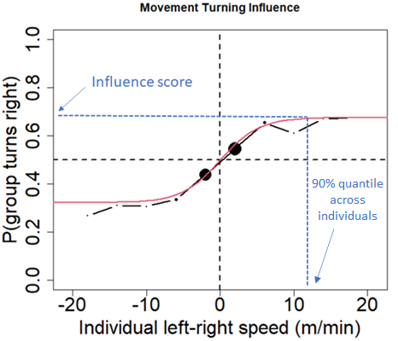**Speed influence**: two metrics to measure the probability that the group’s speed is influenced by a given individual. At any time t, the group’s speed (relative to it’s past speed) was binarized as either speeding up or slowing down. We then looked at the probability that the group had of speeding up as a function of either individual’s front-back position at time t (=**position speeding influence**) or individual’s front-back speed at time t (=**movement speeding influence**)

Figure 2. Example for one given individual of the probability that the group turns right relative to its past direction of travel as a function of that individual speed along the left-right axis. Positive x-values indicates that the individual was moving towards the right of the group relative to past direction of travel, negative values indicate it was moving towards the left. Black curve shows the real data (binned every 4 x-units), red curve shows the fitted line from the modified logistic function, blue dotted lines shows how the influence score is found for that individual.

Modelling turning and speeding influences:

The four measures of influence were modelled by a modified version of the logistic function, allowing the curve to have horizontal asymptotes close to 0 and 1:

$f\left(x\right)= α \frac{1}{1+e^{-βx}} + 0.5 (1-α)$

We fitted a curve separately for each individual and for each of the four influence metrics, by maximizing the log-likelihood (figure 2). Then each curve was synthetized by an influence score taken to be the y-value for a given, fixed value of x (90% quantile across each individual).

We performed GLMM on these influence scores with status as a categorical predictor and group as a random effect to test if there were consistent differences between the influence of each status.

**RESULTS**

**Which individuals spend more time in the front of the group?**

We found the proportion of time spent by each status in the front half of the group relative to direction of travel varied between groups (figure 3). In 3 out of the 5 groups (HM2017, HM2019 and NQ201), the dominant female spent a greater fraction of time in the front half of the group compared to any other individual. In L2019, a lot of individuals spent slightly more time in the front than the dominant female, even though she was overall more often than not in the front. In ZU2021, the dominant female was by far the individual spending the highest proportion of time in the back half of the group. The dominant male was rather more in the back half of the group, except in L2021. No overall trend seems to emerge for other statuses.

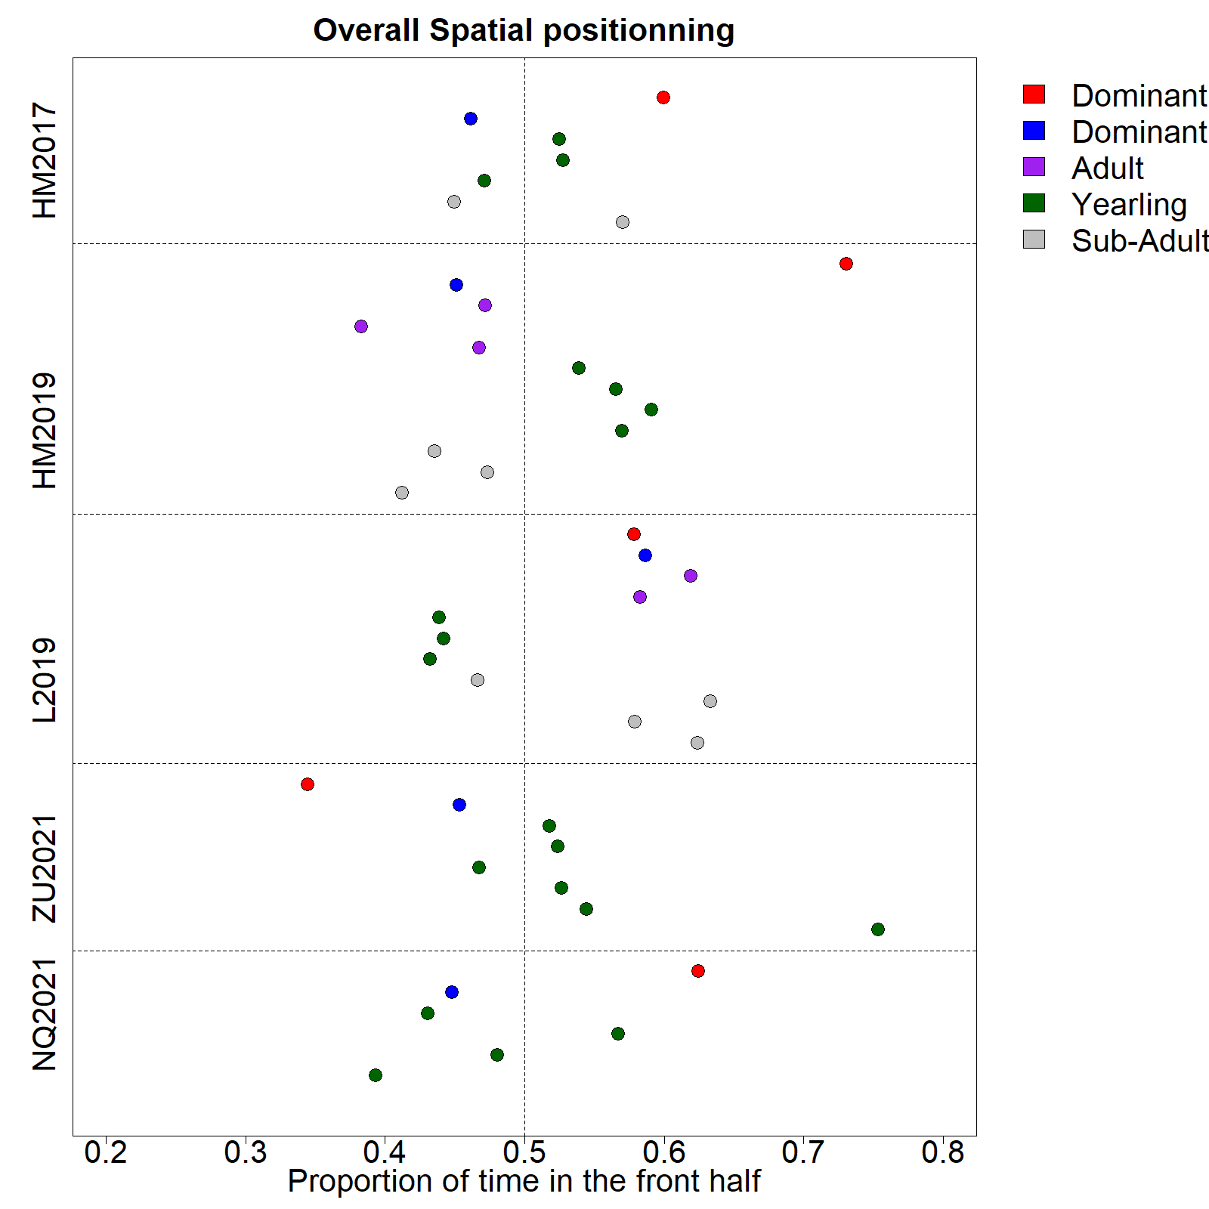

Figure 3. Proportion of time spent in the front half of the group relative to the group’s direction of movement by each recorded individual (colored dots) in the 5 study groups (vertical axis). Dot color indicates individual status as shown in the legend.

**Is the group more influenced by the position or the movement of individuals?**

We modelled the probability of the group to turn right relative to its past direction as a function of each individual’s position and movement along the left-right axis of travel (turning influence). Additionally, we estimated the probability of the group to speed up relative to its past speed as a function of each individual’s position and difference to group speed along the front-back axis of travel (speeding influence). Across all groups, we found a logarithmic relationship whereby group probability to turn right increases sharply as individual movement towards the right increases, before plateauing (figure 2 and figure 4a). Likewise, group probability to speed up increases as individual’s speed relative to the centroid’s along the axis of movement also increases (figure 4b). Individual position along the left-right and front-back axis of movement is also positively correlated with the group probability to turn right or speed up respectively, but to a lesser extent than their movement. We therefore mainly base the rest of our analyses on the role of movement as indicator of decision-making.

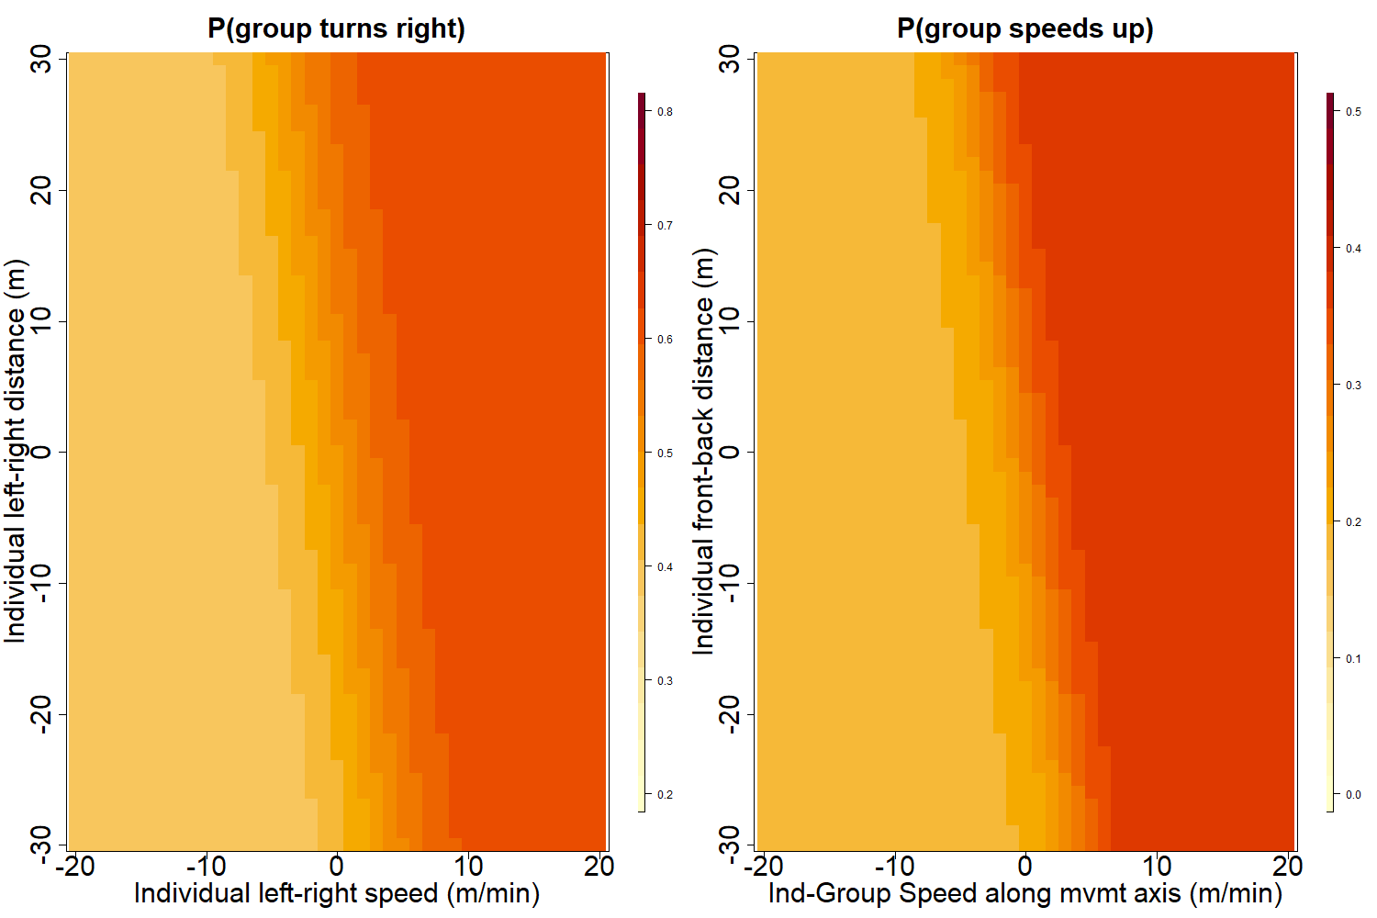

Figure 4. (a) Turning influence: Predicted probability that the group turns towards the right relative to its past direction of movement as a function of individual position and movement along the left-right axis of travel. (b) Speeding influence: Predicted probability that the group speeds up relative to its past speed, as a function of individual position and group-individual difference in speed along the front-back axis of travel.

**How much do different individuals influence direction and timing of movement of the group?**

Based on the fitted logistic curves of turning influence and speeding influence, we attributed a score to each individual for both influence metrics, representing respectively the probability that the group would turn towards the same side this individual was moving to, or would speed up after the individual had sped up toward the front of the group. There was a significant effect of status on the turning influence score (figure 5a, F = 6.76 ; DF = 35 ; p-value = 0.0004), with the dominant female’s score being overall higher than that of any other status. There was no significant difference between the speeding influence score of different statuses (figure 5b, F = 0.88 ; DF = 35 ; p-value = 0.48).

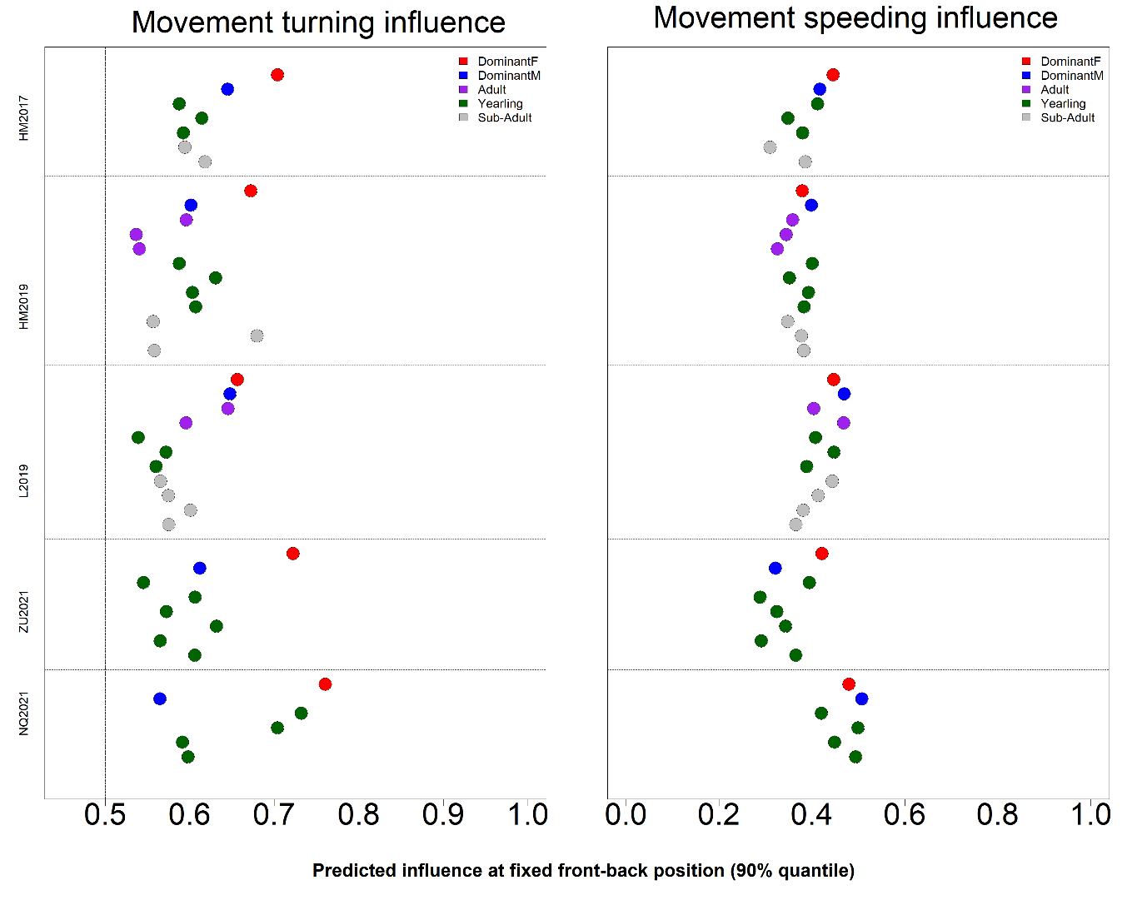Figure 5. Predicted influence scores for each recorded individual (colored dots) in the 5 study groups (vertical axis). Dot color indicates individual status as shown in the legend. (a) Turning influence score represents the probability that the group turns toward the same direction (left or right) that individual was moving to. (b) Speeding influence score represents the probability that the group speeds up after that individual had sped up towards the front of the group.

**DISCUSSION**

In this study we analysed simultaneous trajectories of most individuals in social groups of highly cohesive meerkat in a foraging context. We measured the average position of each individual along the axis of movement, as well as their probability to impact the rest of the group’s direction and timing of travel, in order to infer the patterns of influence among social statuses. The comparison of five groups as well as the use of different, complementary metrics to measure influence allows us to draw nuanced conclusions regarding mechanisms of coordination and social cohesion in meerkats.

We found that overall, the movement of individuals is more important in predicting in which direction the group is going to go next, or when it will accelerate, than their position within the group. Though classical models of collective movement (REF) or controlled studies of moving animal groups (REF) often find individual position to be an important predictor of where other individuals are going to be moving next, our findings support a ‘stop-and-go’ type of movement exhibited by meerkat groups. Indeed, contrary to animals studied before, which tend to be always in motion and for which therefore position in a strong indicator of direction, a lot of the time each individual meerkat is foraging independently from others while the group as a whole is relatively stationary, therefore their position in the group doesn’t necessarily entail the direction where they want to go next. Rather,our results indicate that their likelihood to influence the group’s direction of movement increases with the speed at which they move towards a particular direction. This exemplifies how important the type of movement exhibited by a collective group are in determining the decision-making rules they follow.

When looking for consistent differences between status across our 5 study groups, it appears that the dominant female differs from other members in the goup: she has indeed significantly higher turning influence across all groups, meaning that the rest of the group is much more likely to move towards the same direction where she just moved to, than any other statuses. The dominant male is on the other hand not significantly more likely to attract the other members of the group than the remaining status categories. This pattern is likely explained by the fact that meerkat group territories vary very little within the course of their existence (REF), so individuals who have spent more time within a given group are therefore the most experienced ones in terms of navigating within this group’s home range, and should thus be more likely to be followed by other less experienced individuals. It turns out that dominant males, though often older than their female counterpart, are usually dispersers who grew up in a different group than the one they end up “dominating”, while dominant females don’t disperse and are usually the eldest individuals to have been born in their group (REF). This is the case for all 5 groups we studied here, with the exception of NQ21, where 2 subordinate individuals were born in the same litter as the dominant female, and it is noteworthy that they too had substantially higher turning influence scores than other individuals in their group. It is however surprising that we found no differences in influence between subordinate statuses, as according to our reasoning older statuses would be expected to have more influence. It is thus likely that knowledge of the home range, in combination with dominance status, are traits significantly contributing to increase a meerkat’s high influence on the group’s direction of movement.

On the opposite, there was no significant difference in speeding influence between statuses, meaning that different social statuses had a similar chance of speeding the group up when they were moving faster than the centroid, or slowing it down when moving slower than the centroid. The dominant female therefore seems to have more of a say over the direction of travel of the group, rather than its timing of departure, for which the decisions seems to be more evenly taken by different individuals. Conradt and Roper (2010) predicted that shared decision-making on activity timing was likely to evolve either in social groups where the benefits of group cohesion was low, or where the cost of consensus was high (some individual paying a high price for agreeing on the decision of others). In meerkats, the former can be ruled out as survival chances are drastically reduced for lone individuals (REF). However, individuals within a meerkat group differ a lot in terms of their physical conditions, energy requirements or foraging success, and in addition, the main timing imperative for meerkats is likely to be getting back to one of the sleeping burrows distributed throughout their territory before night falls. Therefore, during the day, successful individuals might pay a low price if the group stays longer in a given foraging patch. Contrary, unsuccessful or more needy ones would, on the opposite, suffer a higher cost if the group departs too early, on the decision of one or a few influential individuals. It would then make sense that decisions regarding timing of departure would be shared across individuals, depending on their specific need at a given moment. Chorum mechanisms, akin to a voting process by which a certain threshold of individuals giving a specific type of call is required for the group to start moving, has already been shown in meerkats (Bousquet et al. 2011), and it would be very interesting to study how this mechanism relates to individual foraging success. Contrary to timing decision, wrong decisions regarding the direction of movement could end up being very costly for all individuals in the groups, as they could end up in a location with little food, no sleeping burrows, or in rival territories. Thus, it makes sense that leaders are more likely to emerge in decisions involving directions, in the traits of more experienced individuals like the dominant female.

The tendency to be in the front of the group is often taken as a proxy for leadership in studies of collective animal movement. Here, in 3 out of the 5 groups we studied, the dominant female spent more time in the front half of the group than any other individual. This would seem in line with our other findings, as it would intuitively make sense for individuals who have high turning influence to be also more in the front. However, in L19, the dominant female spent a similar amount or less time in the front than many other individuals in group, and in ZU21, she is by far the individual who spent the most time in the back of the group, despite having a strong turning influence. This may indicate that individuals in moving social groups don’t necessarily need to be in the top position in order to lead the group, or at least influence it. This might be even more true for species using vocal communication for coordination, as is the case for meerkats. Hearing an influential individual instead of seeing it might be enough to incentivize a change in direction. What follows from this is that the ordering of individuals along the axis of movement alone might be an unreliable metric to infer leadership or influence and should be used in complement with other metrics. Indeed, simply relying on the proportion of time spent in the front would had led to incomplete conclusions regarding patterns of influence in our case. Interestingly, it is worth noting that the one dominant female which was spending more time in the back (group ZU21) had by far the longest tenure at the time of data collection amongst dominant females of our study (104 weeks against 38 weeks maximum). This might be an indication that as a female’s dominancy becomes better and better established within a group, they might become more and more able to influence the group from any position.

Overall, the methodology we presented in this study offers an effective, yet relatively simple, way to infer influence patterns in moving animal groups by separating decisions about timing versus direction of movement. The use of different methods to measure influence as well as the possibility to compare several groups allowed us to nuance our interpretation of the dynamics at play in meerkat during movement. We think this approach highlights the versality of such a trait as influence and therefore the need to study it from different perspective, using when possible several groups, and with a good knowledge of the species’ life history and movement characteristics,. Because of its intended simplicity, our methodology only captures aggregated measures of influence, likely hiding temporal variations in influence patterns. This could be considered in future work by separating group trajectories into different know contexts, based for instance on movement characteristics, or on the acoustic landscape if vocalization data are available. An alternative and maybe complementary method would be to identify particular events in the trajectory, like departure from a patch, sharp changes in direction during movement or production of specific call types, and assess the consistency of influence patterns across them. The methodology we used here has the further benefit of not being species-specific and could be used, with potential expansions or adjustments, in other systems to allow comparisons of the mechanisms at play during decision of timing and direction of movement in different social species.